Provision AWS Persistent DataPlane running on AWS cloud using Terraform
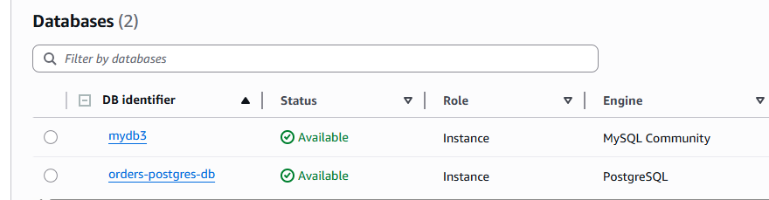

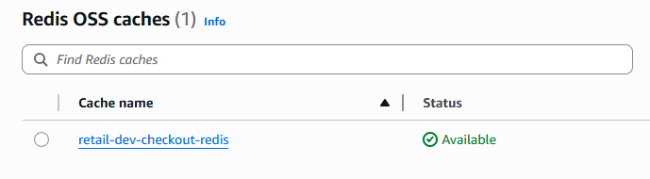
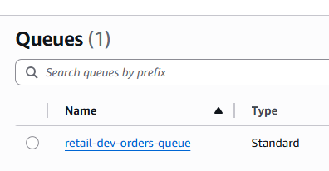

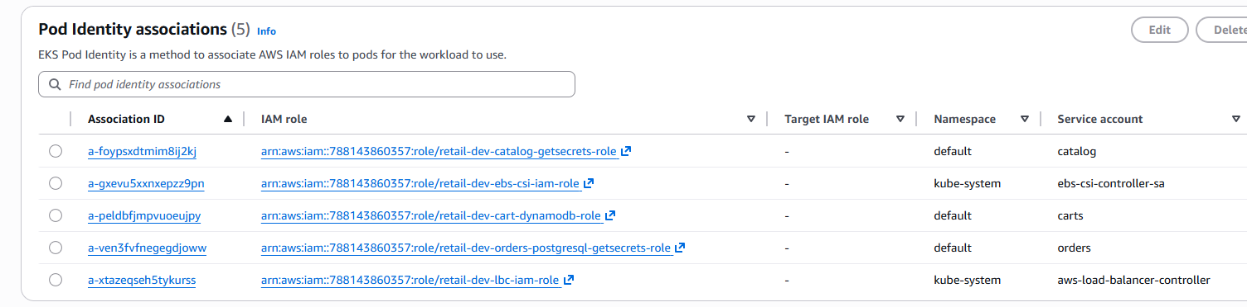
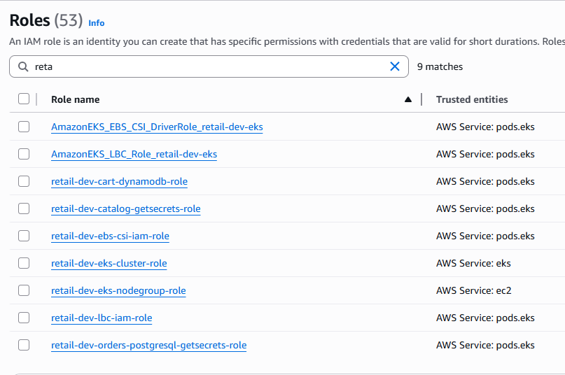

us-west-2
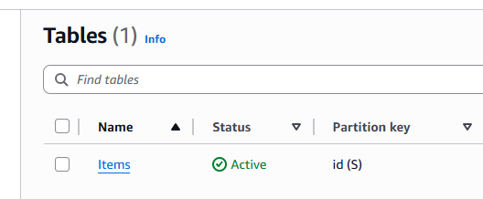

Apply complete! Resources: 24 added, 0 changed, 0 destroyed.

Outputs:

cart_dynamodb_pod_identity_association_arn = "arn:aws:eks:us-east-1:788143860357:podidentityassociation/retail-dev-platform-eks/a-peldbfjmpvuoeujpy"
cart_dynamodb_policy_arn = "arn:aws:iam::788143860357:policy/retail-dev-cart-dynamodb-policy"
cart_dynamodb_role_arn = "arn:aws:iam::788143860357:role/retail-dev-cart-dynamodb-role"
catalog_rds_endpoint = "mydb3.cml0yuu2ka2y.us-east-1.rds.amazonaws.com"
catalog_rds_sg_id = "sg-09ca2b738b5f11490"
catalog_sa_getsecrets_role_arn = "arn:aws:iam::788143860357:role/retail-dev-catalog-getsecrets-role"
catalog_sa_pod_identity_association_arn = "arn:aws:eks:us-east-1:788143860357:podidentityassociation/retail-dev-platform-eks/a-foypsxdtmim8ij2kj"
checkout_redis_endpoint = "retail-dev-checkout-redis.rcapw5.0001.use1.cache.amazonaws.com"
debug_retailstore_secret_password = <sensitive>
debug_retailstore_secret_username = <sensitive>
eks_cluster_id = "retail-dev-platform-eks"
eks_cluster_name = "retail-dev-platform-eks"
orders_postgresql_sa_getsecrets_role_arn = "arn:aws:iam::788143860357:role/retail-dev-orders-postgresql-getsecrets-role"
orders_postgresql_sa_pod_identity_association_arn = "arn:aws:eks:us-east-1:788143860357:podidentityassociation/retail-dev-platform-eks/a-ven3fvfnegegdjoww"
orders_rds_postgresql_db_name = "ordersdb"
orders_rds_postgresql_endpoint = "orders-postgres-db.cml0yuu2ka2y.us-east-1.rds.amazonaws.com:5432"
orders_sqs_policy_arn = "arn:aws:iam::788143860357:policy/retail-dev-orders-sqs-policy"
orders_sqs_queue_arn = "arn:aws:sqs:us-east-1:788143860357:retail-dev-orders-queue"
orders_sqs_queue_url = "https://sqs.us-east-1.amazonaws.com/788143860357/retail-dev-orders-queue"
private_subnet_ids = [
"subnet-0cf4f2754bb68b963",
"subnet-0c0bdbf4b6ee51855",
"subnet-0b953a2b8de791a45",
]
public_subnet_ids = [
"subnet-043c0f9a6a9c9f61f",
"subnet-0cfaf16b9d6497237",
"subnet-0702ba0eb0662fdd1",
]
retailstore_db_secret_policy_arn = "arn:aws:iam::788143860357:policy/retail-dev-retailstore-db-secret-policy"
vpc_id = "vpc-0021188d66a02f65e"

Administrator@DESKTOP-FCQQ0BG MINGW64 /c/devops4sure520/terraform-iac-aws/Terraform_S3_VPC/14_RetailStore_Microservices_with_AWS_Data_Plane/14_01_RetailStore_AWS_Data_Plane/03_AWS_Data_Plane_terraform-manifests (main)
$

